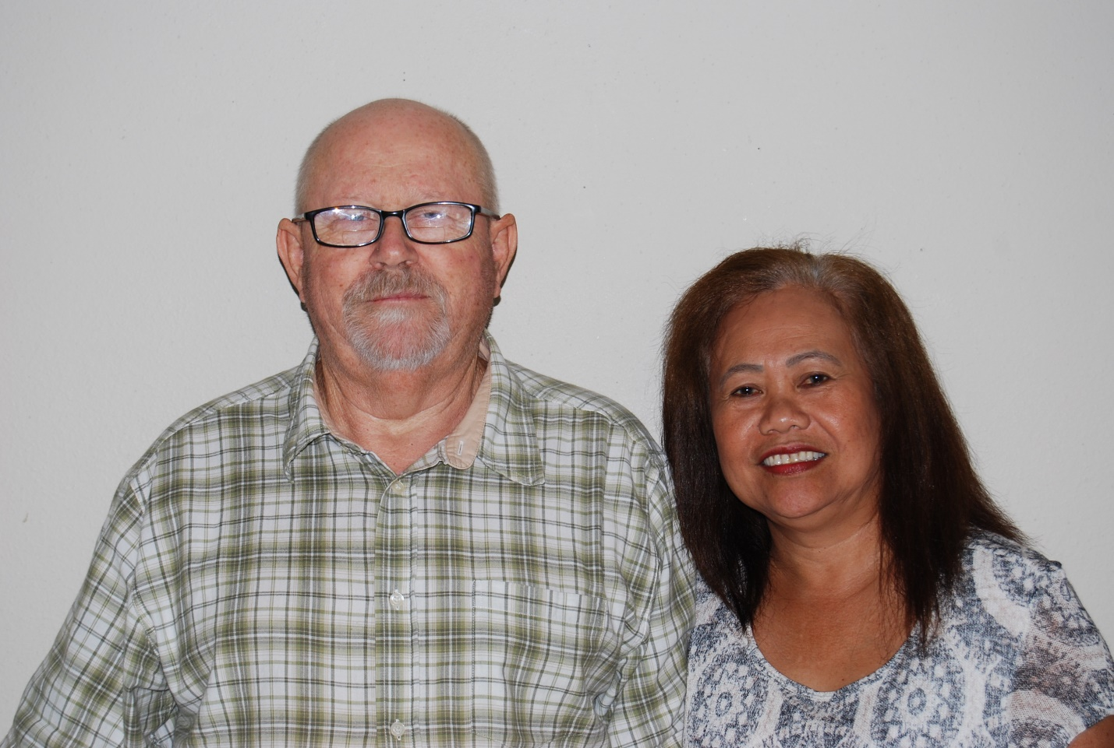
CASEY, Robert & Julita (Lolly)

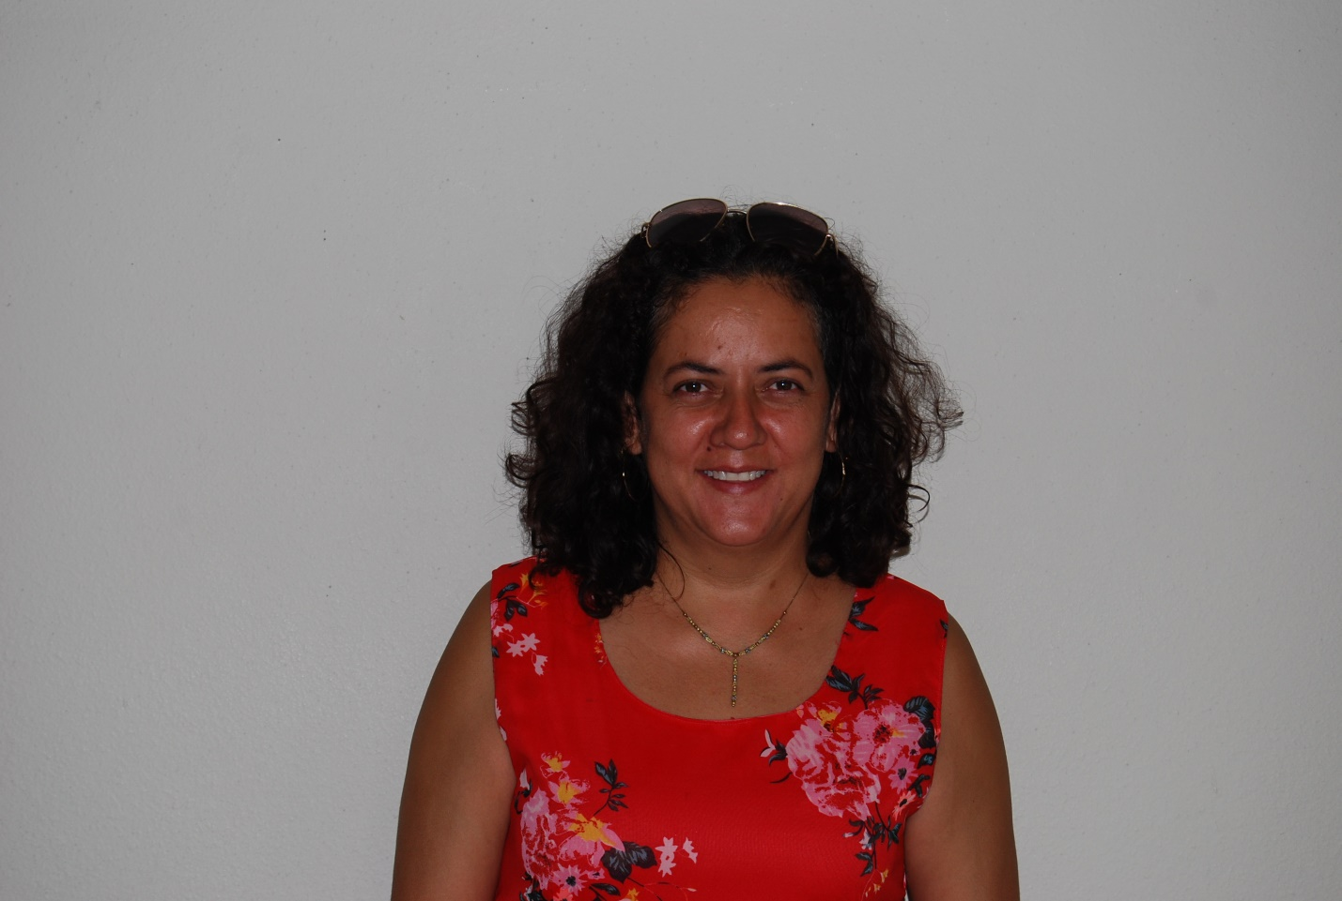

DE LARA, Ana

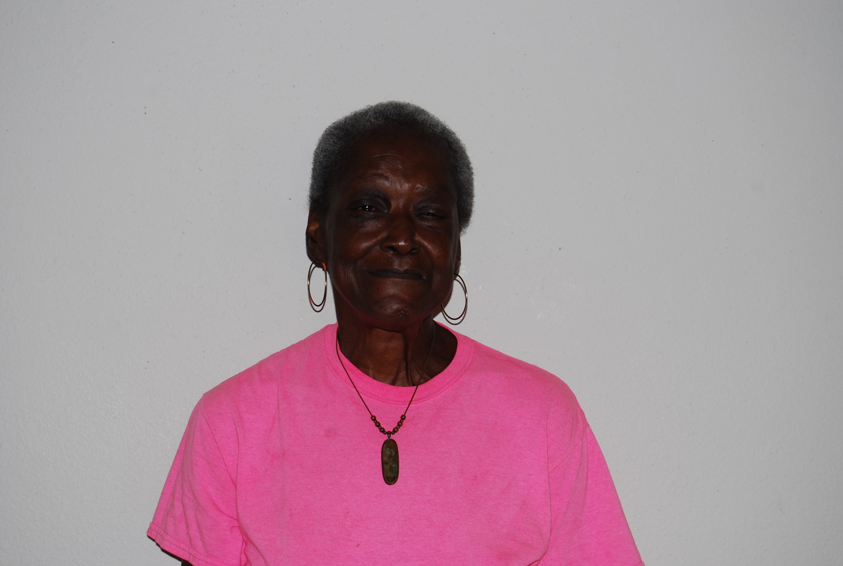
EASON, Olivia

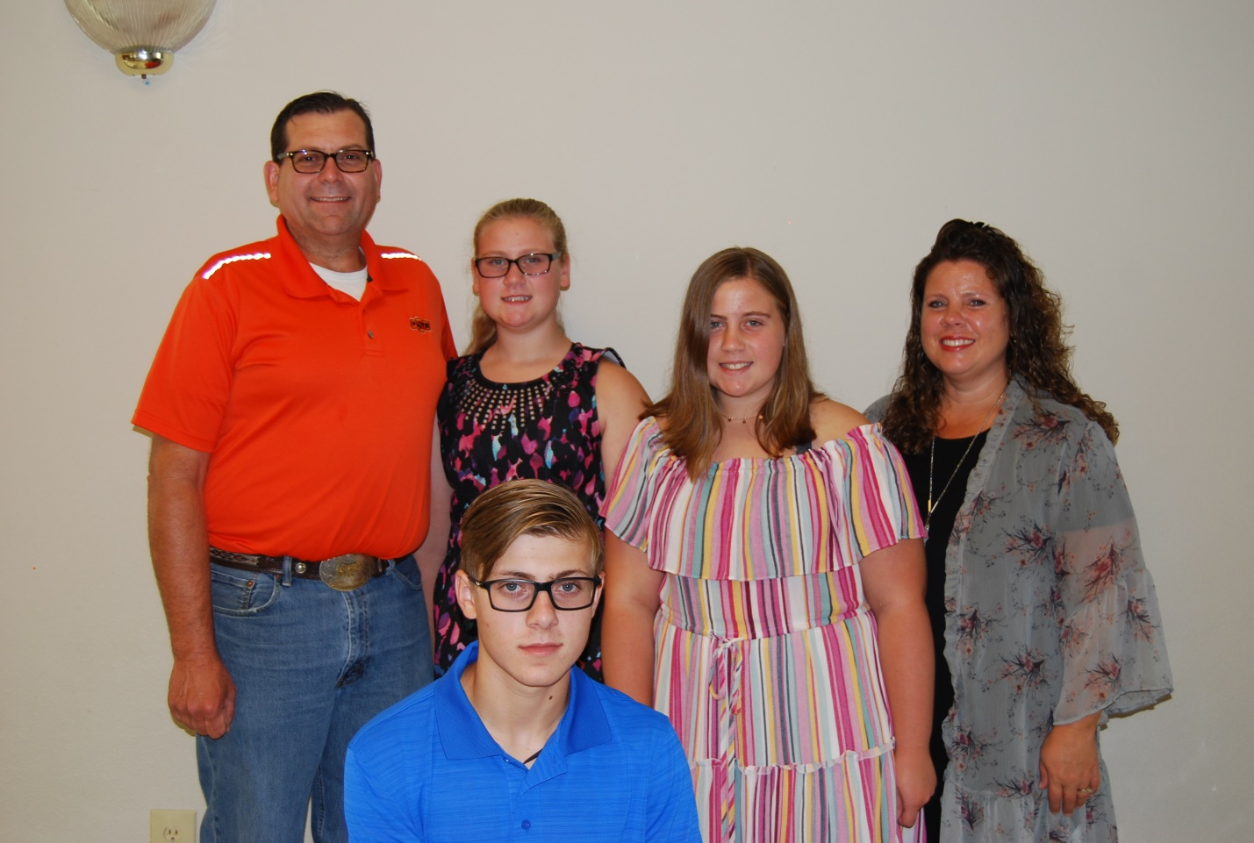

FORTUNE, Mark & Angie, Grace, Mary & Daniel
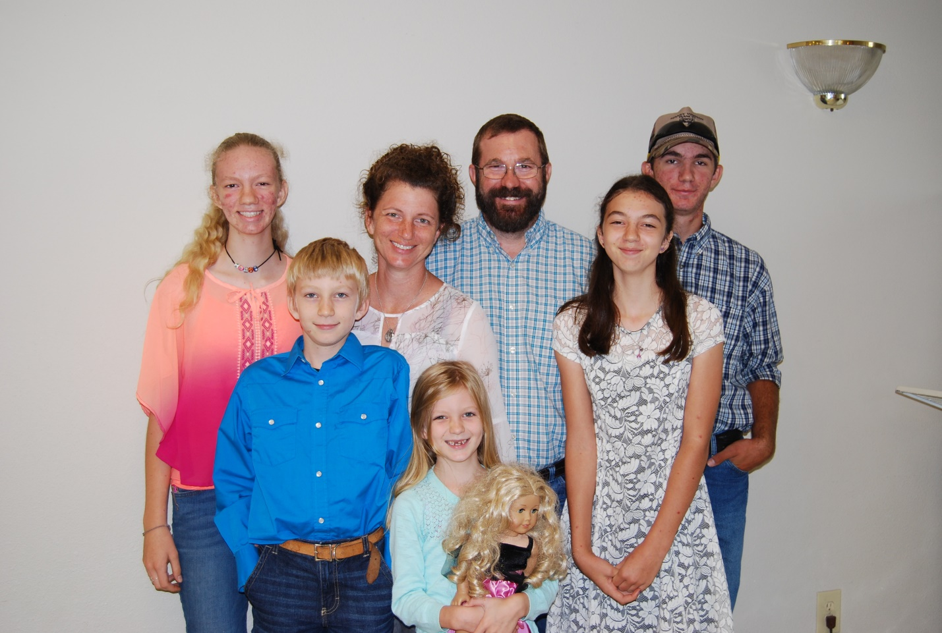

KACHNER, Dale & Ami, Gracie, Bubba, Michael, Lucy & Kenzie

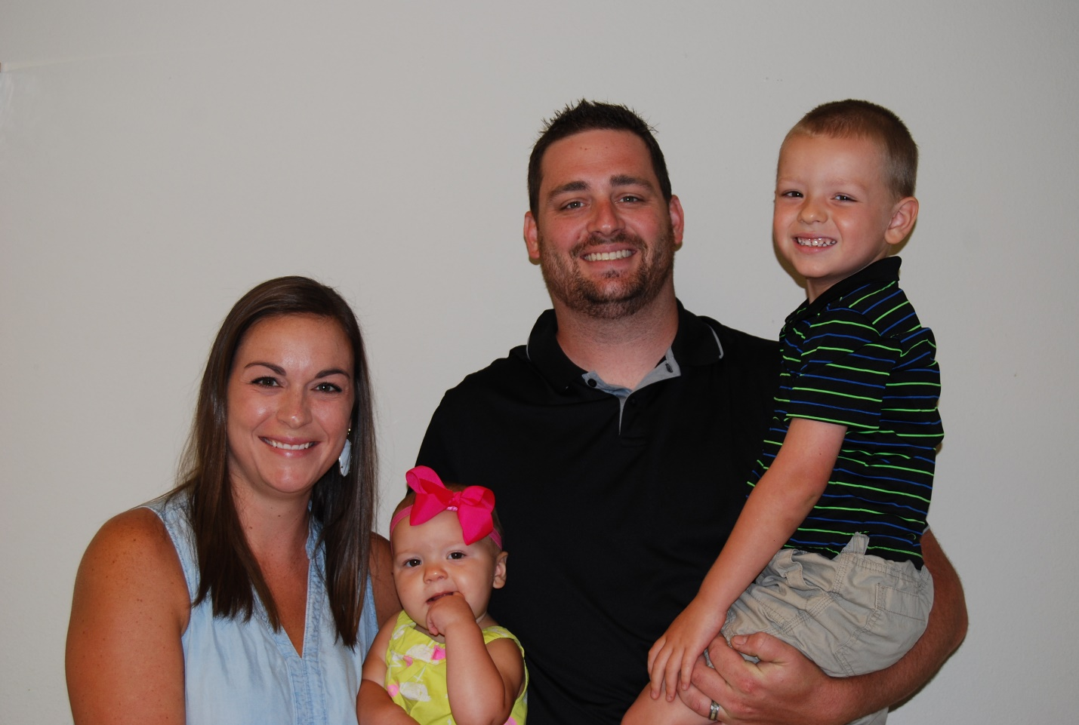
McLAIN, Zac & Kelsey, Carson , Kate Rae
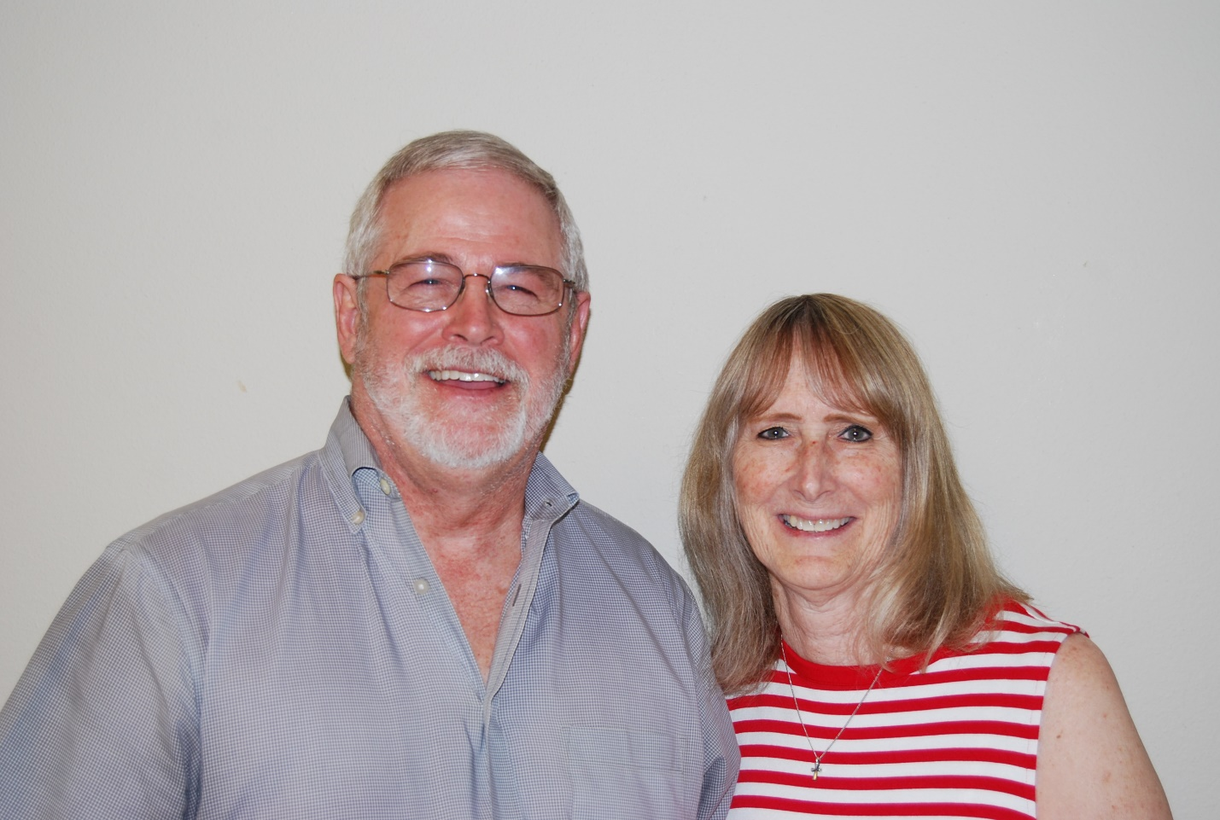
ROBBEN, Keith & Vickie
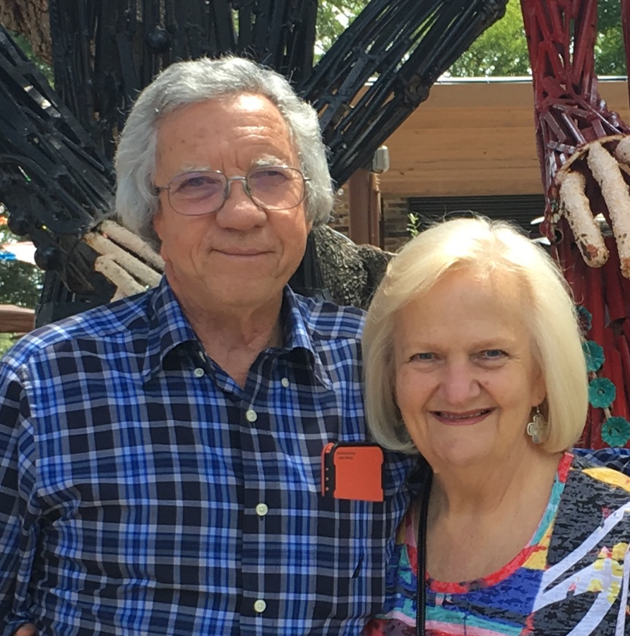
ROTHELL, Calvin & Ilona
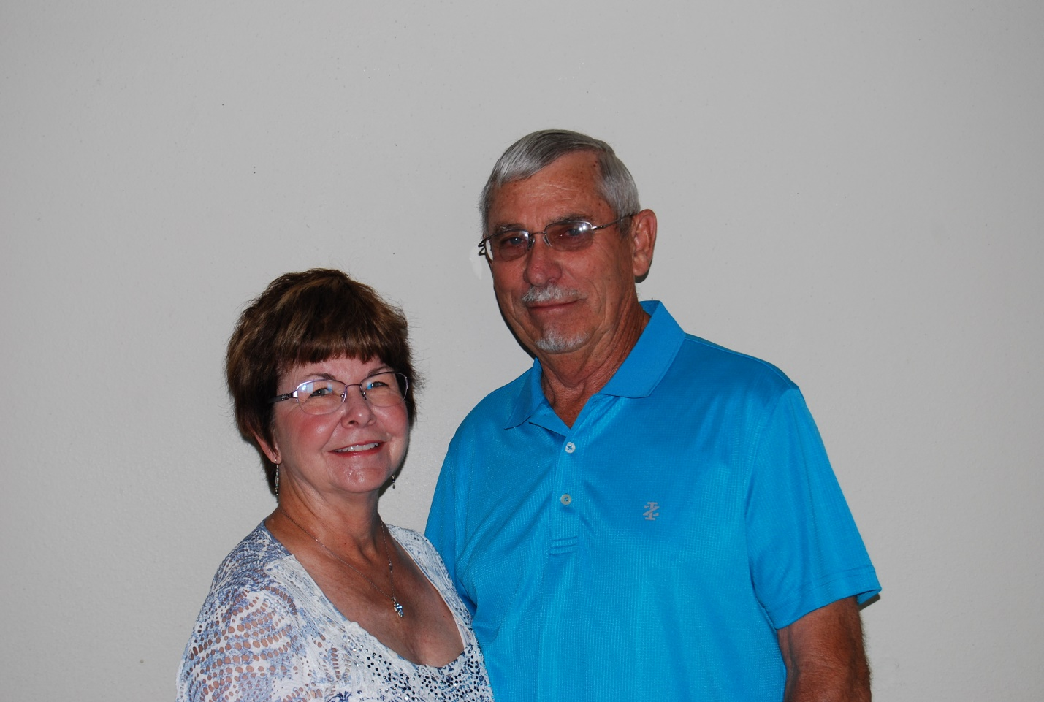
SCHNEIDER, Omer & Betty
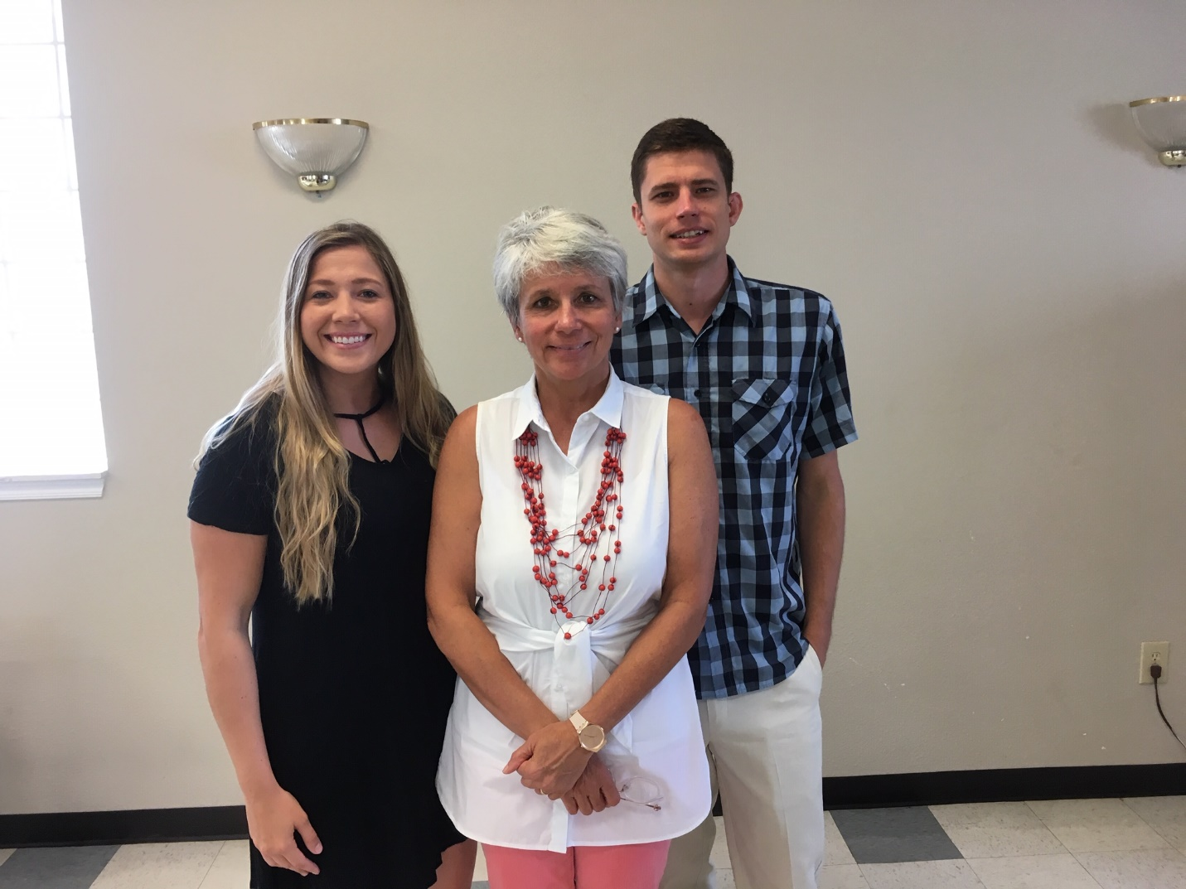

TALBERT, Janice, Lauren & Eric

